Tuesday, February 28, 2023

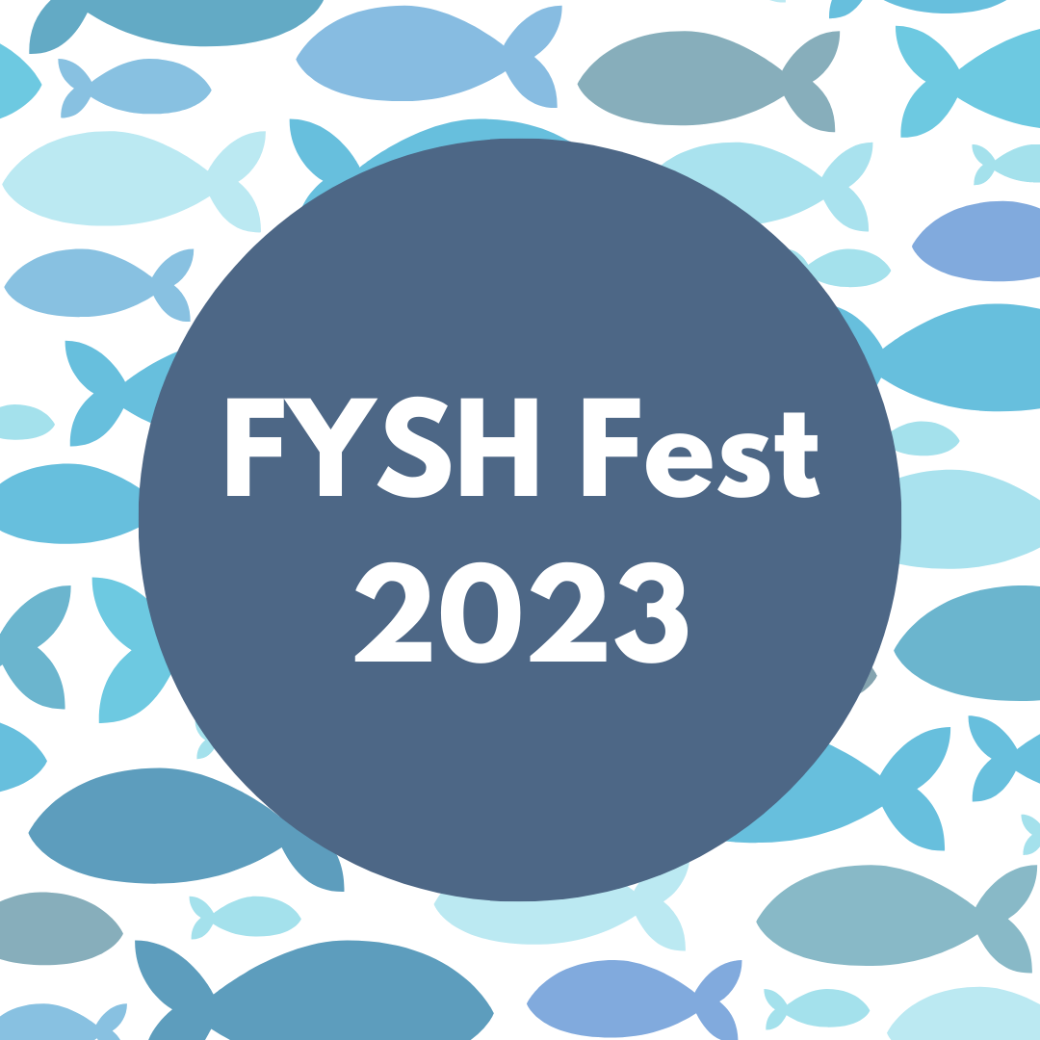
Dear Incoming Class of 2027,

Congratulations on your decision to attend Vanderbilt University and welcome to the First Year Students of Hillel (FYSH) Class of 2027! We are so excited to meet you and want to extend an invitation to you, and the rest of the Class of 2027, to join Hillel on campus a few days early for food, fun, and friends! Register today for FYSH Fest, Vanderbilt Hillel’s fifth annual FREE pre-orientation program.

Our goal is to ensure that you start your Vanderbilt experience with an advantage that most other incoming students do not enjoy. FYSH Fest participants will be shown around campus and will make meaningful connections with peers before moving in. You will also learn more about our Hillel, your Jewish family on campus. We have amazing on-campus and off-campus activities planned for you.

In addition to the other incoming students, you will be joined by a group of student facilitators - hand-picked upperclassmen who have been through it all and want to share all their wisdom. They represent a wide variety of majors, have lived in almost every dorm, come from all over the country, and can tell you about every activity on campus you need to know about. More importantly, they are all leaders on campus and will be there for you with mentorship and support before, during, and after FYSH Fest.

This FYSH Fest packet has all the information that you need to register for our August program. We provide the food, pay for the activities, provide t-shirts, etc. All you have to do is sign up! You can register by filling out our online form by Monday, July 10. The program is FREE for the Class of 2027 thanks to the support of our donors.

Have questions? Call Veronica Grady, Hillel’s Program Director, at (813) 789.1747, or e-mail veronica.l.grady@vanderbilt.edu. She’s here, all summer long, to answer any questions you have about FYSH Fest and campus life in general. Once you sign up, you will get monthly E-mails (starting in May) before the program with additional important information that will make your experience coming to campus super easy.

Don’t miss this amazing opportunity to hang out with us and make an early adjustment to campus life!

Sincerely,

Veronica
Veronica Grady
Vanderbilt Hillel Program Director

Program FAQ

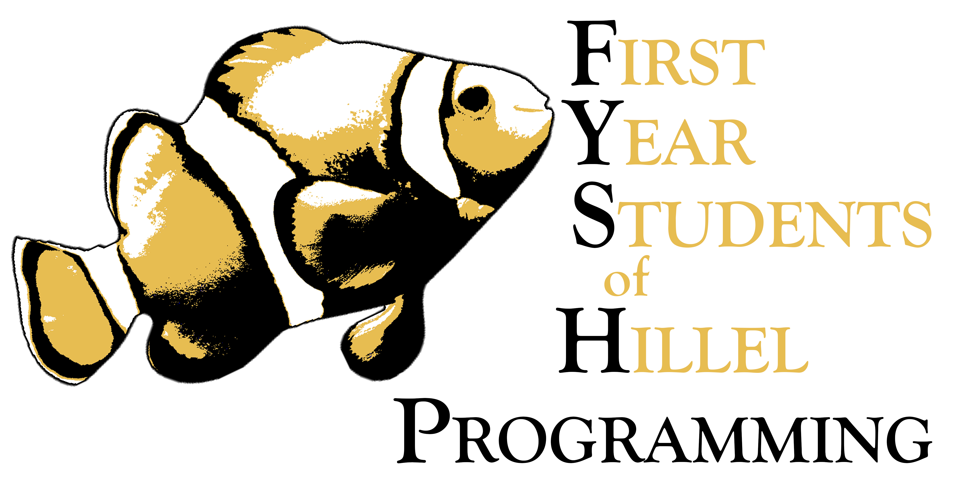
What is a FYSH?
Vanderbilt Hillel has extensive programming for our First Year Students of Hillel (FYSH). This includes our pre-orientation program, FYSH Fest, a mentorship program, a leadership and programming board, and social programming. Keep an eye out for our FYSH Programming all year long!

When does FYSH Fest start?
You will need to be here for FYSH Fest on the Thursday prior to first-year move-in for an evening welcome program and registration. We will have programming all day on that Friday, for students AND parents. The program will conclude with Shabbat on Friday evening and students will move into their dorm rooms on Saturday, with the rest of the Class of 2027.

What is the FYSH Fest Pre-Orientation Program?
FYSH Fest is a pre-orientation program for all incoming students offered by Hillel and coordinated facilitators. Facilitators (we call them FYSH-cilitators) are hand-picked upper-class students that staff the FYSH Fest activities and guide the incoming students as peer mentors. FYSH Fest involves two days of activities on and off campus, culminating in a special Shabbat at the Schulman Center for Jewish Life.

Why participate?
This program is a great way for incoming students to meet upperclassman and peers before the academic year begins. Many of our program alumni have even shared that they made their best friends at Vanderbilt during FYSH Fest. Incoming students also get better acquainted with campus, and get a personal upperclassman mentor matched to them as part of the program, who will be there to guide the start of their college experience.

Who is FYSH Fest for?
Everyone! It doesn’t matter if you are an incoming first-year student or a transfer student. Hillel will offer fun activities for everyone regardless of your Jewish background or interests. All of the food will be provided by Hillel and is under kashrut supervision. Even the most observant Jewish students can enjoy FYSH Fest!

All incoming students are welcome, regardless of their religion.

How do I sign up?
Fill out our online registration form. Follow the instructions provided and book your transportation and hotel. Registration is FREE and includes the food, activities, a t-shirt, and more.

What are you waiting for?
Registration will remain open until Monday, July 10, or we hit our registration cap of student participants. We expect spots to fill quickly. Register TODAY!

Additional Questions?
Do you have any additional questions about FYSH Fest? Call Veronica Grady, Hillel’s Program Director, at (813) 789.1747, or e-mail veronica.l.grady@vanderbilt.edu. She’s here, all summer long, to answer any questions you have about FYSH Fest and campus life in general.

Tips for Parents

When Does My Student Move In?
Your student will participate in Vanderbilt’s scheduled move-in day on Saturday, August 20 and will receive top-notch service from the Vanderbilt move-in crew. Your student will also have the full Vanderbilt Orientation experience.

Where Can My Family Stay?
We recommend making accommodations with hotels within walking distance of Hillel. Consider booking with our partners at Homewood Suites. We will be contacting them shortly to arrange for a special rate for FYSH Fest families:

Homewood Suites by Hilton *
2400 West End Avenue
Nashville, TN 37203
1-615-340-8000

Make sure your reservation extends through the entire weekend so that you can move your student in during Vanderbilt’s move-in-day.

How Long Should My Family Stay?
While FYSH Fest is primarily for the incoming students, we are happy to provide parent-focused programming during FYSH Fest, as well. We can answer all your questions about Hillel and campus life. We can give you important tips about Birthright, Greek Life, Holidays, and much, much more. You are also welcome at our Shabbat on Friday evening with your student. It’s important to note, though, that Hillel respectfully asks families to disengage from their students during the programming schedule on Thursday night and Friday during the day. You’ll have plenty of time to shop and explore Nashville with your students before and after FYSH Fest.

When will the program be over on Friday? Should I make dinner reservations?
FYSH Fest culminates in a time honored tradition of our families and students joining to welcome the first Shabbat of the school year. We are so excited to bring in the joy of Shabbat with you all and are committed to offering something for everyone during the 5:30-6:30pm services window in advance of dinner, including Kabbalat Shabbat songs, Reform and Conservative prayer services, and non-traditional Shabbat discussion-based offerings for EVERY type of Jewish family to enjoy. We understand that this is an important time to get some last family meals and bonding time in before leaving your student at Vanderbilt for the school year, and if you do not plan on joining us for Shabbat dinner we recommend planning for dinner no earlier than 7pm to ensure you can enjoy the closing programming that our student leaders have worked so hard to create, and experience your first Vanderbilt Hillel Shabbat as a family!

Additional Questions?
Call Veronica Grady, Hillel’s Program Director, at (813) 789.1747, or e-mail veronica.l.grady@vanderbilt.edu. She’s here, all summer long, to answer any questions you have about FYSH Fest and campus life in general.
Tips for Parents Continued

Directions to Hillel’s Schulman Center for Jewish Life

From the West:
- Take I-40 East
- Use the right 2 lanes to take exit 206 for I-440 East toward Knoxville
- Continue onto I-440
- Take exit 1 for Murphy Rd toward US-70S E/West End Ave
- Turn left onto Murphy Rd (signs for The Parthenon/West End Ave/US-70S E)
- Use the left 2 lanes to turn left onto West End Ave
- Turn right onto 25th Ave South
- Turn left onto Vanderbilt Place
- Hillel will be the first building on the right

From the North:
- Take I-65 South
- Keep right at the fork to stay on I-65 S, follow signs for I-40 W/Huntsville/Memphis
- Use the left 2 lanes to take exit 84B for I-40 W toward Memphis
- Continue onto I-40 W
- Follow directions 2-9 for coming from the West

From the South:
- Take I-65 North to Nashville
- Use the right 2 lanes to take exit 80 to merge onto I-440 West toward Memphis
- Take exit 1 to merge onto US-70S East/West End Ave
- Merge onto US-70S East/Highway 1 East/West End Ave
- Turn right onto 25th Ave South
- Turn left onto Vanderbilt Place
- Hillel will be the first building on the right

From the East (Airport):
- Merge onto I-40 West
- Use the left 3 lanes to take exit 213A for I-440 W toward Memphis
- Follow directions 3-7 for coming from the South

Helpful Destinations

College Shopping Needs:
Wal-Mart Supercenter
(615) 352-1240
7044 Charlotte Pike
Nashville, TN 37209

Target
(615) 352-8461
26 White Bridge Road
Nashville, TN 37205

Bed, Bath, and Beyond
(615) 646-7383
7657 Highway 70 South
Nashville, TN 37221

Markets (With Kosher Options):
Kroger
(615) 269-5649
4560 Harding Pike
Nashville, TN 37205

Trader Joe’s
(615) 356-1066
90 White Bridge Rd
Nashville, TN 37205

Accommodations:
Homewood Suites by Hilton
2400 West End Avenue
Nashville, TN 37203
1-615-340-8000

Or another Vanderbilt Campus-area hotel

Thursday, August 18, Arrive in Nashville
Time | Location | Description
5:45 – 6:45 p.m. | Vanderbilt Hillel | Hillel Welcome Cookout  Come to Hillel to check into the program and for a welcome dinner cookout. Mingle and meet the other families.  Parking is limited in the Hillel lot and is reserved for families needing accessible parking or special accommodations. No parking is permitted in the Medical Center side of the facility.  Limited parking may be available on Vanderbilt Place and surrounding streets. However, participants are encouraged to please consider walking to the Schulman Center from their hotels if possible.
6:45 – 8:00 p.m. | Vanderbilt Hillel | Family ONLY – Reception  Families are invited to join the Hillel staff for an after-dinner dessert reception and schmooze-fest on our back patio.
6:45– 7:30 p.m. | Vanderbilt Hillel  Upstairs | Student Ice Breakers and Dessert  Hillel’s student leaders will introduce themselves and help you get to know each other.
7:30 – Late-Night | Downtown Nashville | Evening Activity  Get to know your fellow FYSH and the FYSHcilitators with a fun off-campus adventure.
11:00 p.m. | Vanderbilt Hillel | Come and Get Your Students  If you are a hotel beyond walking distance, please come and pick up your student from Hillel for the night. Too late or don’t have transportation? Hillel will take care of your student and make sure they get back to you.

Friday, August 19, Programming
Please wear your FYSH Fest shirts!
Time | Location | Description
9:15 – 10:00 a.m. | Vanderbilt Hillel | Good Morning Breakfast!  Grab a Nashville nosh before the FYSH Fest program commences for a full day of programming.  Parking is limited in the Hillel lot and is reserved for families needing accessible parking or special accommodations. No parking is permitted in the Medical Center side of the facility.  Limited parking may be available on Vanderbilt Place and surrounding streets. However, participants are encouraged to please consider walking to the Schulman Center if possible.
10:00 – 11:00 a.m. | Vanderbilt Hillel | Family ONLY - Everything You Need to Know to Have a Happy Jewish College Student & Light Refreshments  Hear about all the important tips and tricks you need to know to support your college student (including some things you won’t hear from Vanderbilt). Topics will include: Birthright, Greek life, Jewish holiday observance, safety tips, and more.
10:00 – 11:00 a.m. | Vanderbilt Hillel | Student Panel  Our FYSH will have the opportunity to ask FYSHcilitators their burning questions about campus life, academics, social opportunities, Hillel, and WHATEVER else they may be wondering as they begin their college journeys!
11:00 – 12:00 p.m. | Leave from Vanderbilt Hillel | Student Campus Tour  Wondering where your classes are? We have you covered. We will provide personalized tours that will make sure you are navigating through your first day of classes with ease. You’ll end your tour with a lunch at a location on 21st Ave.
11:00 – 12:30 p.m. | Leave from Vanderbilt Hillel | Family Tour of Campus  Hana, a student tour guide and FYSH Fest Co-Chair, will take the families around campus to show them everything they show on the University tours and more.
12:00 – 12:30 p.m. | Location TBA | Student Lunch  Enjoy a delicious lunch on 21st Avenue (location TBA) before we leave campus for our second excursion!
12:30 – 3:30 p.m. | Nashville | Nashville Day Out  Enjoy a fun excursion to a local hot spot.
3:30 p.m. – 5:30 p.m. | Vanderbilt Hillel | Hillel Activity Fair  Choose your own adventure! Based on the selections you made before FYSH Fest, participate in 3 activities with Hillel student leaders to get a taste of what kinds of programs and communities you can get involved with this year!
5:30 – 8:00 p.m. | Vanderbilt Hillel | Shabbat Services & Dinner  Take a rest and enjoy our student-led Shabbat services, including Reform, Conservative, and Secular offerings, followed by a delicious kosher catered dinner of all of Hillel’s favorites (including Goldie’s brisket).

